Algebra I
Definitions

Integers- A whole number that is written without fractions.

Expression-is a mathematical phrase that contains numbers, operators and/or variables.

Numerical Expression- A mathematical expression that consists of only numbers and operators.

Algebraic Expression- is a mathematical expression that consists of constants, variables and operators (+, - , * , / )

Variable- a letter that represents a changing number. Typically a letter at the end of the alphabet (i.e. x , y , z).

Constant- a number that does not change. Can also be represented by a letter (typically at the beginning of the alphabet i.e. a, b, c)

Coefficient- A number that is multiplied by a variable.

Fraction- Represents a part of a whole.

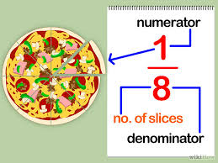

Factors- Numbers when multiplied together give you a product.

Example
(4x + 1) * (2x - 3) = 100

The factors are in Red

Terms- parts of an expression that are added.

Example
22x + 17y

The Terms are in Blue.

