- Definition-A statement that clarifies or explains the meaning of a word or phrase. Point, line and plane are undefined even though they are the basis for all Geometry.

- Point-Most basic building block. No size. Only has a location. Represented as a point. Labeled with a capital letter.
. Point P

- Line-A straight and continuous arrangement of infinitely many points. No thickness. Extends forever. Name a line by giving the letters of any two points and putting a line symbol above it.
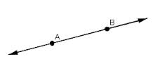
$↔$
AB

- Plane-Has length and width, but know thickness. A flat surface that that extends infinitely along its length and width. Labeled with a capital script letter.
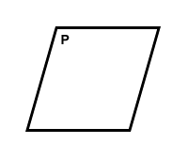 i.e. Plane P
- Collinear-Means points on the same line
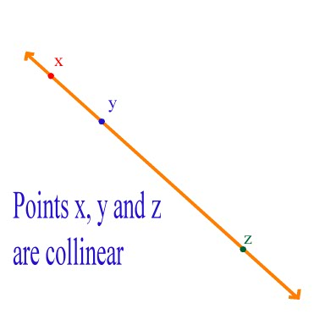

- Coplanar- Means on the same plane.
i.e. Points A, B and C are Coplanar
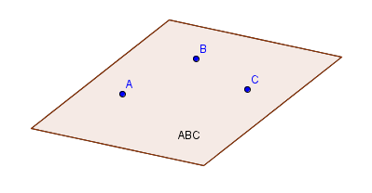
- Line Segment- Two points called end points of the segment and all the points in between are collinear. The are labeled with the line segment symbol-a simple line.

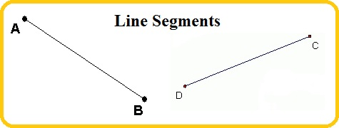
$-$ $-$
i.e. AB DC

- Congruent- Have equal measures or lengths.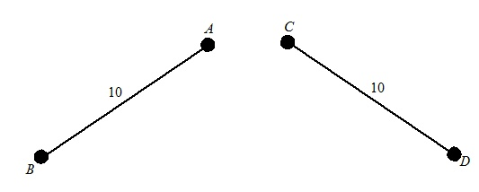 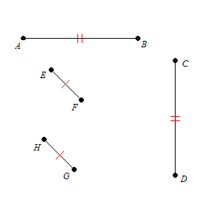

- Midpoint – The point on a line segment that is the same distance from both endpoints.
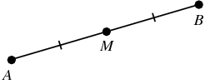

- Ray- Begins at one point and goes in one direction indefinitely
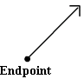 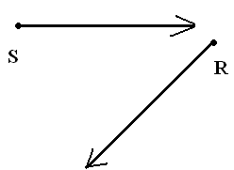i.e. Rays S and R

