All information will be saved in a word document in order for you to submit electronically
Save in this format: FirstLastNameGeometry#Hour
Problem One
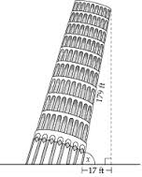
Step 1. Using internet resources locate information on the Tower of Pisa. And include the following:
Example Picture (attach image to fit):

Location: City of Pisa, Italy
Dimensions:
Height | 55.86 meters
Diameter at Base | 15.84 meters
Interior Diameter | 7.36 meters
Five Facts about Tower of Pisa:
- Add your information here
- Briefly tell why it is interesting
- Share information most people would not know
- Could be about history
- Could be trivial information

Step 2. Set up a right triangle for the problem below with the information you have acquired. (You may have a few educated guesses)
You can use your picture to draw on or create a triangle to setup your problem. Example:

179ft

90°
x
17ft

Resources: SOH-CAH-TOA The Tan (x) = 179feet/17feet
Solve for angle x. Angle x = 84.57°

